NVOLVE
Podcast Project: RadiaLogue
By Phani and Tina

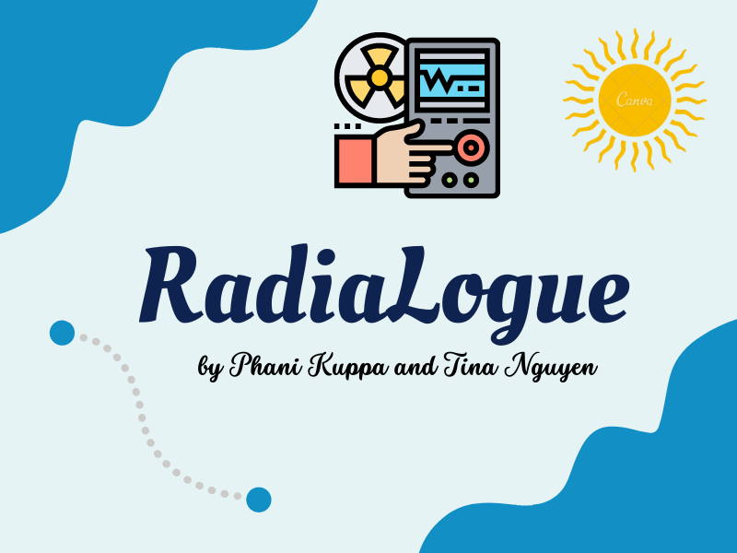

Overview
As we are both majoring in Engineering, we came up with many kinds of related physics topics. After we brainstormed with our coach, we decided to talk about radiation. We have learned that radiation exists everywhere in our daily life, so humans are exposed to radiation that they might acknowledge or not. To be more specific, people now spend more time on technology devices than in the past, so the chance of being exposed to radiation is higher than people who spend less time on these devices. Radiation has impacts on human life as it is applied in industry, medical, and other fields, but the exposure to radiation over a long period of time is an issue for human health. Therefore, people should be informed about what radiation is, how it affects human health, and how humans should minimize their chances of being exposed to radiation. Our podcast is a short and informative yet fun way to learn about radiation and why you need that information. From our conversation, we hope our audience can be inspired and motivated on what they should know about radiation.
Outcome
Tina: I have learned how to do research on a science topic by gathering sources and sorting out which one is the best to be the part of our talk, meaning that the knowledge I provide for the listeners should be clear, precise, and was approved by some accredited organizations. Moreover, I knew how to prepare a script and warm-up my voice before recording an episode. I believe that any smooth recording should have a well-prepared script behind, so I tried to edit and proofread my script every time before I headed to the recording process. After that, I practiced reading out my script several times so that I felt confident to record my voice. Finally, I have learned how to use many tools to make up my podcast channel. To record my voice, I used the record application on my phone. To make a poster for our podcast channel, I used a tool called Canva to design and add texts. To publish our talk publicly, I registered with Anchor to upload our recorded files.
Phani: I have learned how to make a challenging STEM subject enjoyable for both the audience and myself. I also learned how to make the script flow like a conversation and how to use conversational cues throughout to make it feel more natural. There are also some minor changes that can make a significant effect, such as learning how to enunciate and acquiring confidence to sound more intentional in the episodes. The most compelling aspect of creating this podcast was recording and assembling the components. At first, I was confused on how to record our voices and then combine our separate audio clips together. We were able to use only our phones entirely remotely with the assistance of our mentor and my friends who have some experience in this area. Voice Memos and iMovie were the applications that we utilized to bring the podcast together.
Sources:
https://www.iaea.org/newscenter/news/what-is-radiation
https://www.mirion.com/learning-center/radiation-safety-basics/the-history-of-radiation
https://www.center4research.org/children-cell-phones-phone-radiation-risky-kids/
Links to our podcast:
- Spotify: https://open.spotify.com/show/2cMtQ5erYskWuSVihnP8EX
- Podcasters: https://podcasters.spotify.com/pod/show/tina-nguyen59

